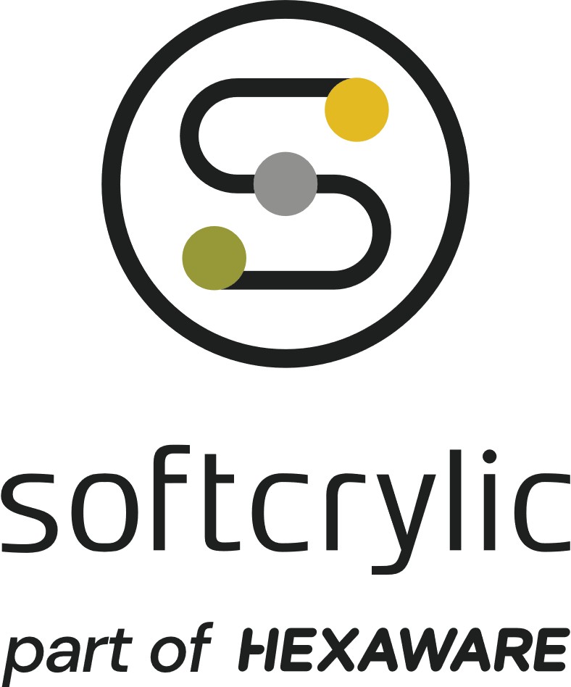

# Profile Summary:

# A versatile, problem solver who has built multiple teams from scratch and delivered various products and services. He also holds a PG Diploma in AI / ML. Prior to Softcrylic, He co-founded Palmtrix Technologies, a start-up organization of fering technology solutions to educational institutions. He has formulated tailor made processes for different business needs and implemented, measured and driven them on the ground.

# Work Experience

## Softcrylic Technology Solutions India Pvt Ltd Mar 2023 to till date.

Designation: Sr. Consultant – Data Science & Analytics

## Freelancer IT Consultant Aug 2019 to Mar 2023

## Softcrylic Technology Solutions India Pvt Ltd Mar 2014 to Feb 2018

Project Manager

## Palmtrix Technologies 2011 to 2013

(Co-Founder)

## Infosys Technologies 2005 to 2010

QA Tester/Lead

# Technical Skills

* Excel
* Power Query
* JIRA
* MPP
* Google Sheets
* Python
* Statistics for DS
* Data Analytics
* Tableau
* Data OS
* EDA, NLP, Machine Learning
* Neural Networks
* MY SQL
* JMeter
* Blazemeter
* qTest
* Applitools
* Browserstack
* SauceLabs

# Project Details

**Project#1:**

**Project Name:** **Mar 2023 to till date.**

**Designation**: -

## Project Description:

## Project #2:

**Project Name:**  **Aug 2029 to Mar 2023**

## Designation:

## Project Description:

## Responsibilities:

## Project #3:

**Project Name:** Waggle **Aug 2029 to Mar 2023**

## Designation: Project Manager

## Project Description:

## Responsibilities:



# EDUCATION